## **Angular Routing**

1. At first create project in angular
2. Add ng bootstrap and ng fontawesome which are especially designed for angular

[FortAwesome/angular-fontawesome: Official Angular component for Font Awesome 5+ (github.com)](https://github.com/FortAwesome/angular-fontawesome)

<https://ng-bootstrap.github.io/#/home>

1. Then create login, forgot password and not found page
2. Font awesome can be use like this

1. Create modules

1. Now create dashboard component inside the modules

1. File structure

1. Now add default routing in ‘admin-routing.modules.ts’

1. Now add this as a lazyRouting in main routing

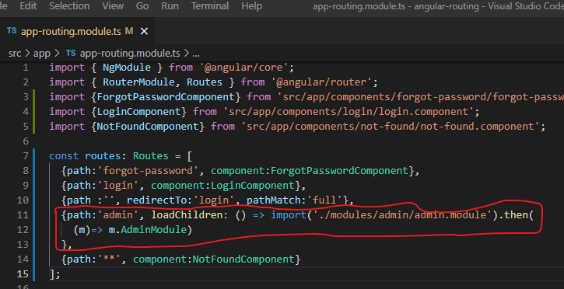

What happened here is that red circle will not be load until it is called

On the demand only we load this, and this make it our project faster

1. Now generate few more components

1. Now set up routing things (in admin routing)

Here AdminDashboardComponent act as a parent and other like home, about act as a children

Header and footer will be inherited in all components

1. Now protect router

To protect the router, we use canActivate Guard

1. Create services

Write code in ‘auth.service.ts’

1. Now apply all of these in login

* First make reactive form
* First inject auth and router in login

* dfdf

1. Now add these codes on auth guards

1. Now create function to logout (in header component)

